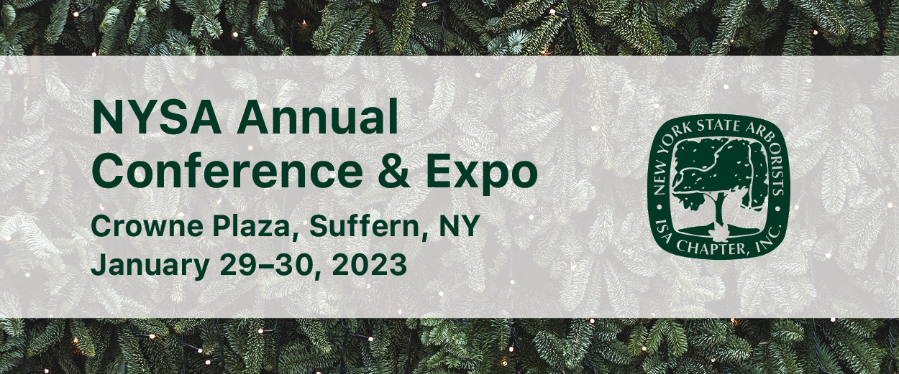

Schedule of Events
Sunday, January 29
8:00-11:30 am ISA Certified Arborist, Utility Specialist, Municipal Specialist, and Certified Tree Worker Written Exam (RENAISSANCE I)
10:00 am-6:00 pm Registration Desk Open (Montebello Ballroom Foyer)
12:00-1:10 pm Opening General Session: Tree Risk Assessment, from Simple to Complex - Philip van Wassenaer, Principal Consulting Arborist, Urban Forest Innovations, Inc. Tree risk assessment is an evolving discipline, combining art and science to inform important decisions about tree maintenance and management. The discipline has evolved over time from simple visual assessment to invasive drilling-based techniques, and finally to minimally-invasive, engineering-based methods. Today, a comprehensive tree risk assessment may draw on any number of tools and techniques to provide as good an evaluation of the risk presented by trees as possible. The presentation will provide an overview of the science and theory of risk, cover a range of tree risk assessment techniques, and highlight the latest advancements in this important field. As a result, audience members will leave with a better understanding of what is involved in tree risk assessment, the limitations of traditional and advanced techniques, and the role of the risk assessment expert in challenging assessments. (MONTEBELLO BALLROOM)

1:20-2:30 pm DEC Session: On the Offensive – Updates on Spotted Lantern Fly and Beech Leaf Disease – Dan Gilrein, Extension Entomologist, and Margery Daughtrey, Senior Extension Associate, Cornell Cooperative Extension. Dan will review the current situation in NY with spotted lanternfly and box tree moth including management and response options, as well as updates to the Pest Management Guidelines and other entomological news of interest to arborists. Margery will describe what is known about the life cycle of the beech leaf nematode, Litylenchus crenatae subsp. mccannii, and how it interacts with its hosts. She will cover the expansion of the disease across the northeast and the impact it is having on American and European beeches. Assessing the effectiveness of management techniques with fungicides and cultural measures will be discussed. (HUDSON BALLROOM)
1:20-2:30 pm Tree Academy: Trees and Pavement – Jason Grabosky, Professor, Rutgers School of Environmental and Biological Sciences. Trees generally grow to the site insomuch as the trees respond to their environment, whether light, water, nutrition or space. Because of the this, and due to the fact that in a designed urban site environmental challenges are often exaggerated, trees in association with pavement are beset with challenges in the soil and in the above-ground space. Design choices have consequences, so when dealing with pavement we discuss both space for rooting volume and provision of water. There are a series of planting or design strategies on the market, so we will look at some of the general strategies. We can also look at recent and ongoing research to better understand design expectations in growth, and the impact on pavement, in other words, what to expect in the designs the tree management professional inherits. (RENAISSANCE I)

2:30-3:00 pm Refreshment Break with Vendors—open through the afternoon (MONTEBELLO BALLROOM FOYER & HUDSON BALLROOM HALLWAY)

3:00-4:10 pm DEC Session: Massaria Disease of Plane, Part 1: Identifying and Understanding Massaria – Greg Packman Senior Tree Inspector, London Borough of Islington. Massaria is a fungal disease affecting trees of the genus Platanus. It has been widespread in European cities and a significant management concern for over a decade. Massaria is a risk-related tree management issue as the fungus degrades and weakens the wood of branches in plane trees, which can in turn lead to a sudden branch failure. Given that Massaria develops as a hard to see lesion on the upper side of the branch, identification and management of Massaria can be a challenge. This presentation explores the visual symptoms as Massaria develops from first symptoms to branch death, how to identify Massaria branches from the ground, and an understanding of the biology of the fungus to explore how Massaria develops within a tree. (HUDSON BALLROOM)
3:00-4:10 pm Tree Academy: Does Biology Trump Biomechanics? – Dr. Chris Luley, President, Urban Forest Diagnostics LLC. When assessing trees for decay arborists are often focused on quantifying the extent of decay and the potential for tree failure. This focus may overlook the impact of the biological factors that affect decay progression, which ultimately may be more important in failure prognosis than the biomechanics and decay quantification. (RENAISSANCE I)

4:15-4:55 pm Personal-Care Session: First Aid for Arborists – John Economou. (HUDSON BALLROOM)
4:15-4:55 pm Business-Care Session: Transitioning to Electric Power Tools – Jared Gavzy, Owner, Eco-Quip. (RENAISSANCE I)

5:05-6:15 pm DEC Session: The Conifer Conundrum – Beth Brantley Plant Pathologist, Bartlett Tree Experts. Climate change, cultural conditions and pests and pathogens present challenges for many coniferous species. This presentation will review species in decline, health issues, and opportunities for alternative species. Bark beetles, scale insects, phytophthora root rot and foliar fungi will be featured. (HUDSON BALLROOM)
5:05-6:15 pm Tree Academy: Working with Hispanic Employees – Sandra Lopez Cortez, Scott Arboretum of Swarthmore College with panelists. Many Hispanics face a variety of challenges, and it is not necessarily always an option for Hispanics to pursue an education. We have a lack of college-going culture, and we don't always have all the resources on how to navigate the process to continue higher education. Who we are does not always correlate with what we are dreaming of. I will share my personal story on how I got into the field of horticulture and hope that we can start brainstorming ideas on how to engage and integrate other Hispanics more deeply into the field of arboriculture and related fields. (RENAISSANCE I)

6:15-7:30 pm Meet & Greet Reception with Vendors & 50/50 Raffle (MONTEBELLO BALLROOM)

Monday, January 30
6:30 am-3:00 pm Registration Desk Open (MONTEBELLO BALLROOM FOYER)
7:00-8:30 am Tree and Plant Appraisal Committee Meeting (LAFAYETTE SUITE)
7:00-8:30 am Networking Breakfast – Peer-to-Peer Discussions on Current Arboriculture Trends and Issues Join the conversation with our speakers and industry leaders discussing current issues and trends affecting the arboriculture industry. (MONTEBELLO BALLROOM)
7:00-8:30 am Breakfast with the Vendors (MONTEBELLO BALLROOM FOYER & HUDSON BALLROOM HALLWAY)

8:30-9:40 am Spanish Language Session: Seguridad en buckets truck – Leo Roldan, Entrenador de seguridad, SavATree. Los elevadores aéreos montados en camiones se hicieron comunes en la década de 1950. Esto permitió que más trabajadores accedieran a los bucket trucks para operaciones de arboricultura. Hubo alrededor de 2400 incidentes con dispositivos aéreos (bucket truck ) durante la última década que resultaron en una visita al servicio de urgencias. Muchos de estos incidentes fueron caídas cuando la pluma fue golpeada por una rama que caía, lo que provocó que el operador cayera de la plataforma, un escenario común para los trabajadores de árboles también. (WASHINGTON SUITE)
8:30-9:40 am DEC Session: New York State Spotted Lanternfly Update – Anne Mills, Assistant Horticulture Inspector I, Michael Formichelli, Horticultural Inspector-1, NYS Department of Agriculture & Markets. What do you need to know to help your community manage spotted lanternfly as an arborist, nurseryperson, landscaper, and horticulturalist? These topics plus information on reporting spotted lanternfly and what you can do to help reduce the local population will be covered. (HUDSON BALLROOM)
8:30-9:40 am Tree Academy: Funding for Municipal Arboriculture – Danielle Gift, Northeast Urban & Community Forestry Coordinator, US Forest Service. Urban forestry involves all of us. Through partnerships, the US Forest Service invests from the ground up to establish, restore, maintain, and improve community trees and forests. Urban & Community Forestry (UCF) is a cooperative program of the USFS that focuses on the stewardship of urban natural resources; raises awareness of the importance of trees in sustaining healthy cities and communities; improves the social, natural, and economic environment; and enables the development of self-sufficient local programs. Through this program, the Forest Service provides technical, financial, research, and educational services to local governments, non-profit organizations, community groups, educational institutions, and tribal governments. This presentation will cover many of these services, with specific focus on technical and financial assistance. (RENAISSANCE I)

9:40-10:10 am Refreshment Break with Vendors (MONTEBELLO BALLROOM FOYER & HUDSON BALLROOM HALLWAY)

10:10-11:20 am Spanish Language Session: El arte de podar árboles y arbustos pequeños – Sandra Lopez Cortez, Jardinera II, Scott Arboretum of Swarthmore College. Definitivamente hay una ciencia y un arte en la poda. La poda adecuada implica la eliminación de ramas muertas o vivas para una buena salud estructural. El arte de podar es lograr los objetivos de podar de una manera que sea estéticamente agradable. Se discutirán algunas de las técnicas que usamos en el arboreto de Scott, tales como monte bajo, polarding y espaldera. (WASHINGTON SUITE)
10:10-11:20 am DEC Session: Massaria Disease of Plane, Part 2: Managing Massaria – Greg Packman, Senior Tree Inspector, London Borough of Islington. The presence of Massaria can result in an increased level of management, to manage the risk posed by potential branch failure. This could range from an increased inspection frequency to altered species selection. This presentation is based on the experiences of managing Massaria Disease of Plane in London, from core documentation such as 'Common Sense Risk Management of Trees' and the best practice management guidance on Massaria by the London Tree Officers Association. The presentation will cover parts of the inspection process, tree management practices and the legal duties faced in the UK. (HUDSON BALLROOM)
10:10-11:20 am Tree Academy: PPE Required of an Employer – Mike Tilford, Director of General Tree Care, SavATree. Personal Protective Equipment can be the last line of defense between a worker and severe injury, or worse. In this session we will explore the relevant standards and requirements for employers, as well as the consequences of inaction. (RENAISSANCE I)

11:30 am-1:00 pm Association Luncheon with Association Business Meeting, Board elections, Industry Awards & Tree Fund Heads & Tails Raffle (MONTEBELLO BALLROOM)

1:00-2:10 pm DEC Session: NYSDEC Rules, Regulations and the Use of Unregistered Products Update – Catherine Ahlers, Pesticide Control Specialist II, NYS Department of Environmental Conservation. What’s new from the New York State DEC? This informative talk will include an update on DEC regulations as well as what other regulations warrant a review. (HUDSON BALLROOM)
1:00-2:10 pm Tree Academy: Reduce the Crown, Retain the Tree – Philip van Wassenaer, Principal Consulting Arborist, Urban Forest Innovations, Inc. The presentation examines aspects of crown reduction from several different perspectives. An understanding of natural tree survival strategies informs management approaches for aging trees. Large pruning wounds can lead to significant decay and structural weakness but if too little is cut, the tree may break, also causing large wounds. How do we find the appropriate dose? The techniques used for maintaining aging trees can also be applied to younger trees and trees damaged by storms. Case studies and examples will be presented to illustrate the concepts and techniques described above. (RENAISSANCE I)

2:20-3:30 pm DEC Session: DEC Barstool Session – Don Nelson, Section Chief, NYS Department of Environmental Conservation. Don will sit down with you to provide updates and answer your questions about, “What’s new from the New York State DEC?” and provide information about regulations. You may submit your questions at registration in advance of the session. (HUDSON BALLROOM)
2:20-3:30 pm Tree Academy: Inspecting your PPE – Mike Tilford, Director of General Tree Care, SavATree. Personal Protective Equipment can be the last line of defense between a worker and severe injury, or worse. In this session we will explore the relevant standards and requirements for employees, as well as the consequences of inaction. (RENAISSANCE I)

