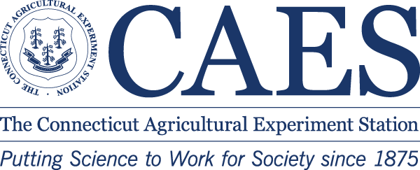

NURSERY & LANDSCAPE RESEARCH TOUR
Thursday, September 15, 2016

The Connecticut Agricultural Experiment Station
Valley Laboratory, 153 Cook Hill Rd., Windsor, CT 06095

8:30 REGISTRATION
Walk through CAES/CNLA Education Garden

9:00 WELCOME Dr. Jim LaMondia

Walking Tour

9:05 Updates on biological control of HWA in CT Dr. Carole Cheah
9:25 Growing Hops in Connecticut Dr. Katja Maurer
9:45 Water Issues: Soils and Landscapes Mr. Tom Rathier
10:05 Crop Safety Herbicide Trials for Container Ornamentals Dr. Jatinder Aulakh
10:25 The Latest on Boxwood Blight Dr. Jim LaMondia

10:45 BREAK

Indoor Talks

11:00 Neonicotinoid Insecticides Research Results Dr. Rich Cowles
11:30 Common Cultural/Disease Problems 2015 -16 Dr. Yonghao Li
11:50 White Pines in the CT Landscape Dr. Yonghao Li, Rose Hiskes
12:10 Common Insect/Herbicide Problems 2015 -16 Ms. Rose Hiskes, Jatinder Aulakh
12:30 Push for Pollinator Habitat: Needs for Plants and Seeds Dr. Kim Stoner

1:00 ADJOURN – Pesticide Recertification Credits Available, 3.25 hours

